Papers written by
Australian Maths Software

REVISION 3

2016

MATHEMATICS
METHODS
Units 1 & 2

Semester 2
SOLUTIONS

SECTION 1 – Calculator-free
Question 1 (3 marks)
✓
A x intercept
✓
B y intercept; local maximum point; turning point
C Local minimum point; turning point ✓
Question 2 (29 marks)
(a) 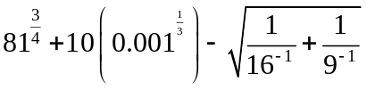
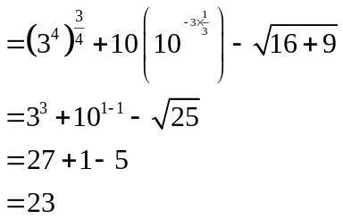
✓✓✓

✓

✓

(b) (i) 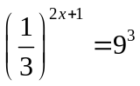
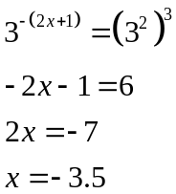
✓
✓
✓

(ii) 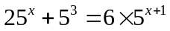
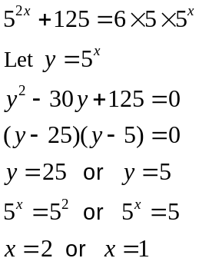
✓
✓
✓

(iii) 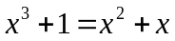
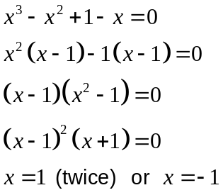
✓
✓
✓

(b) 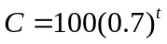
✓
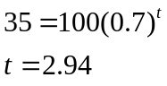
✓
✓
Relief of 2 hours 57 minutes

Question 3 (6 marks)
(a) 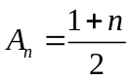
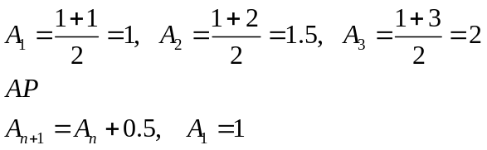
✓
✓
✓

(b) (i) 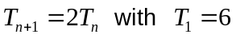
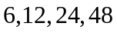 ✓
(ii) GP a = 6, r = 2
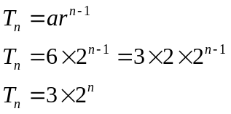
✓
✓

Question 4 (4 marks)
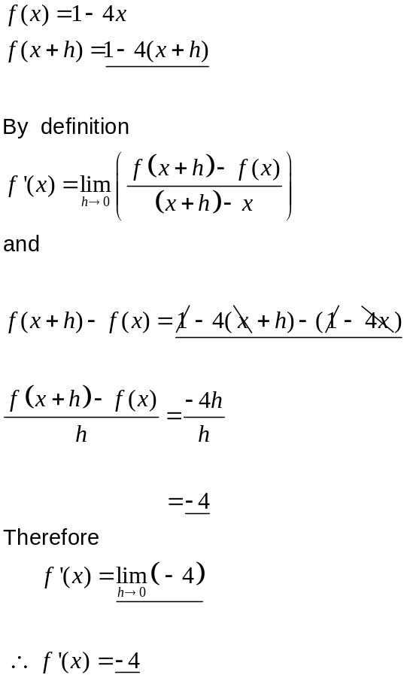
✓
✓
✓
✓
Question 5 (10 marks)
(a) (i)
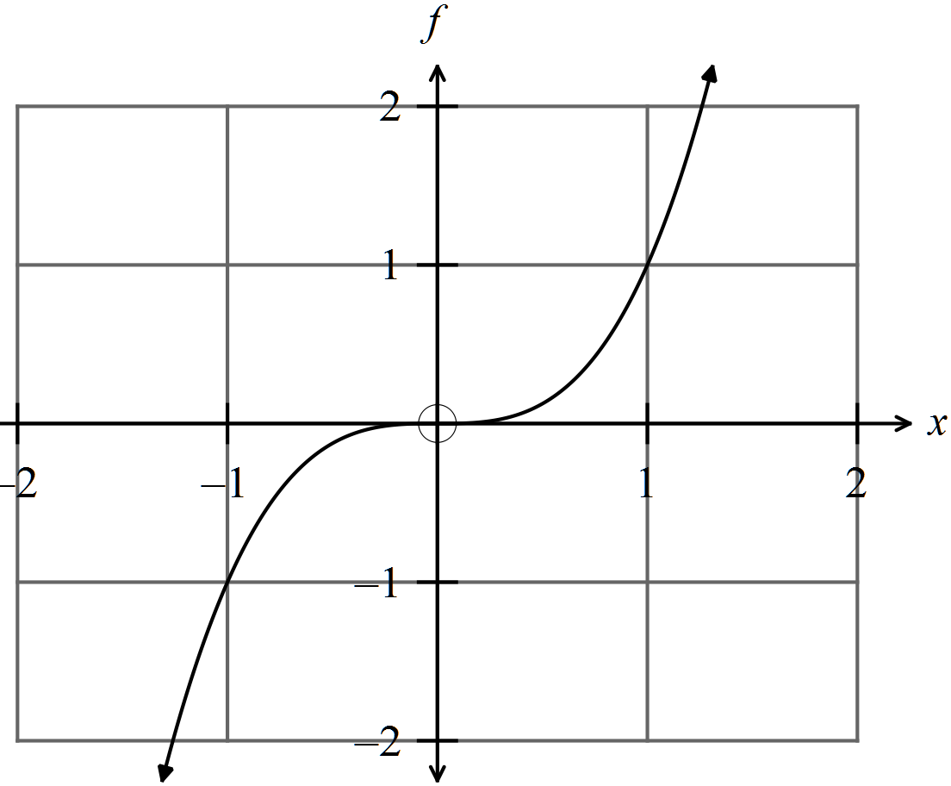
✓
✓ general shape
✓
✓
✓✓

(ii) 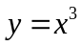

(b) (i) 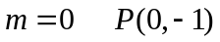
✓
✓

(ii) 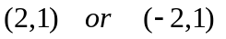
✓

(iii) B is an x intercept. ✓
Question 6 (13 marks)

(a) 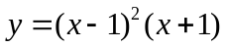
✓✓ ✓

(b) 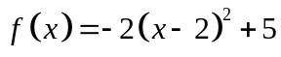
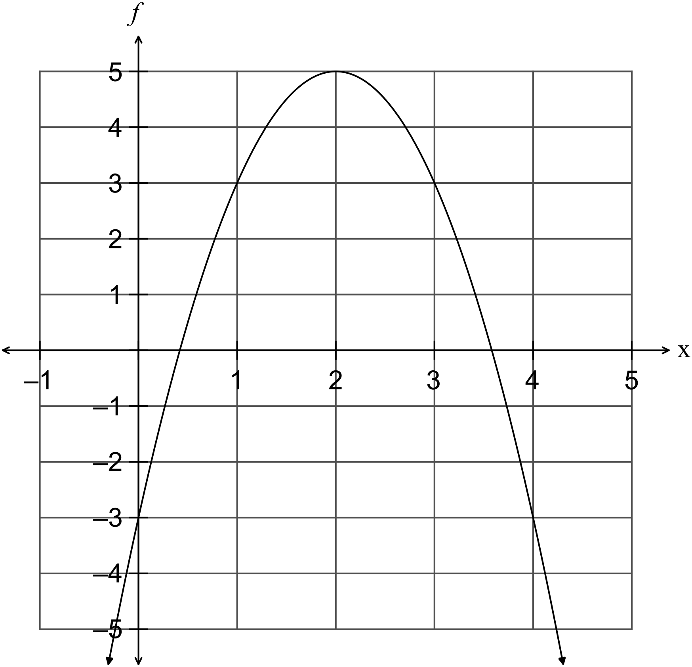
✓
✓✓ concavity, x intercepts

✓
(c) 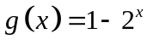
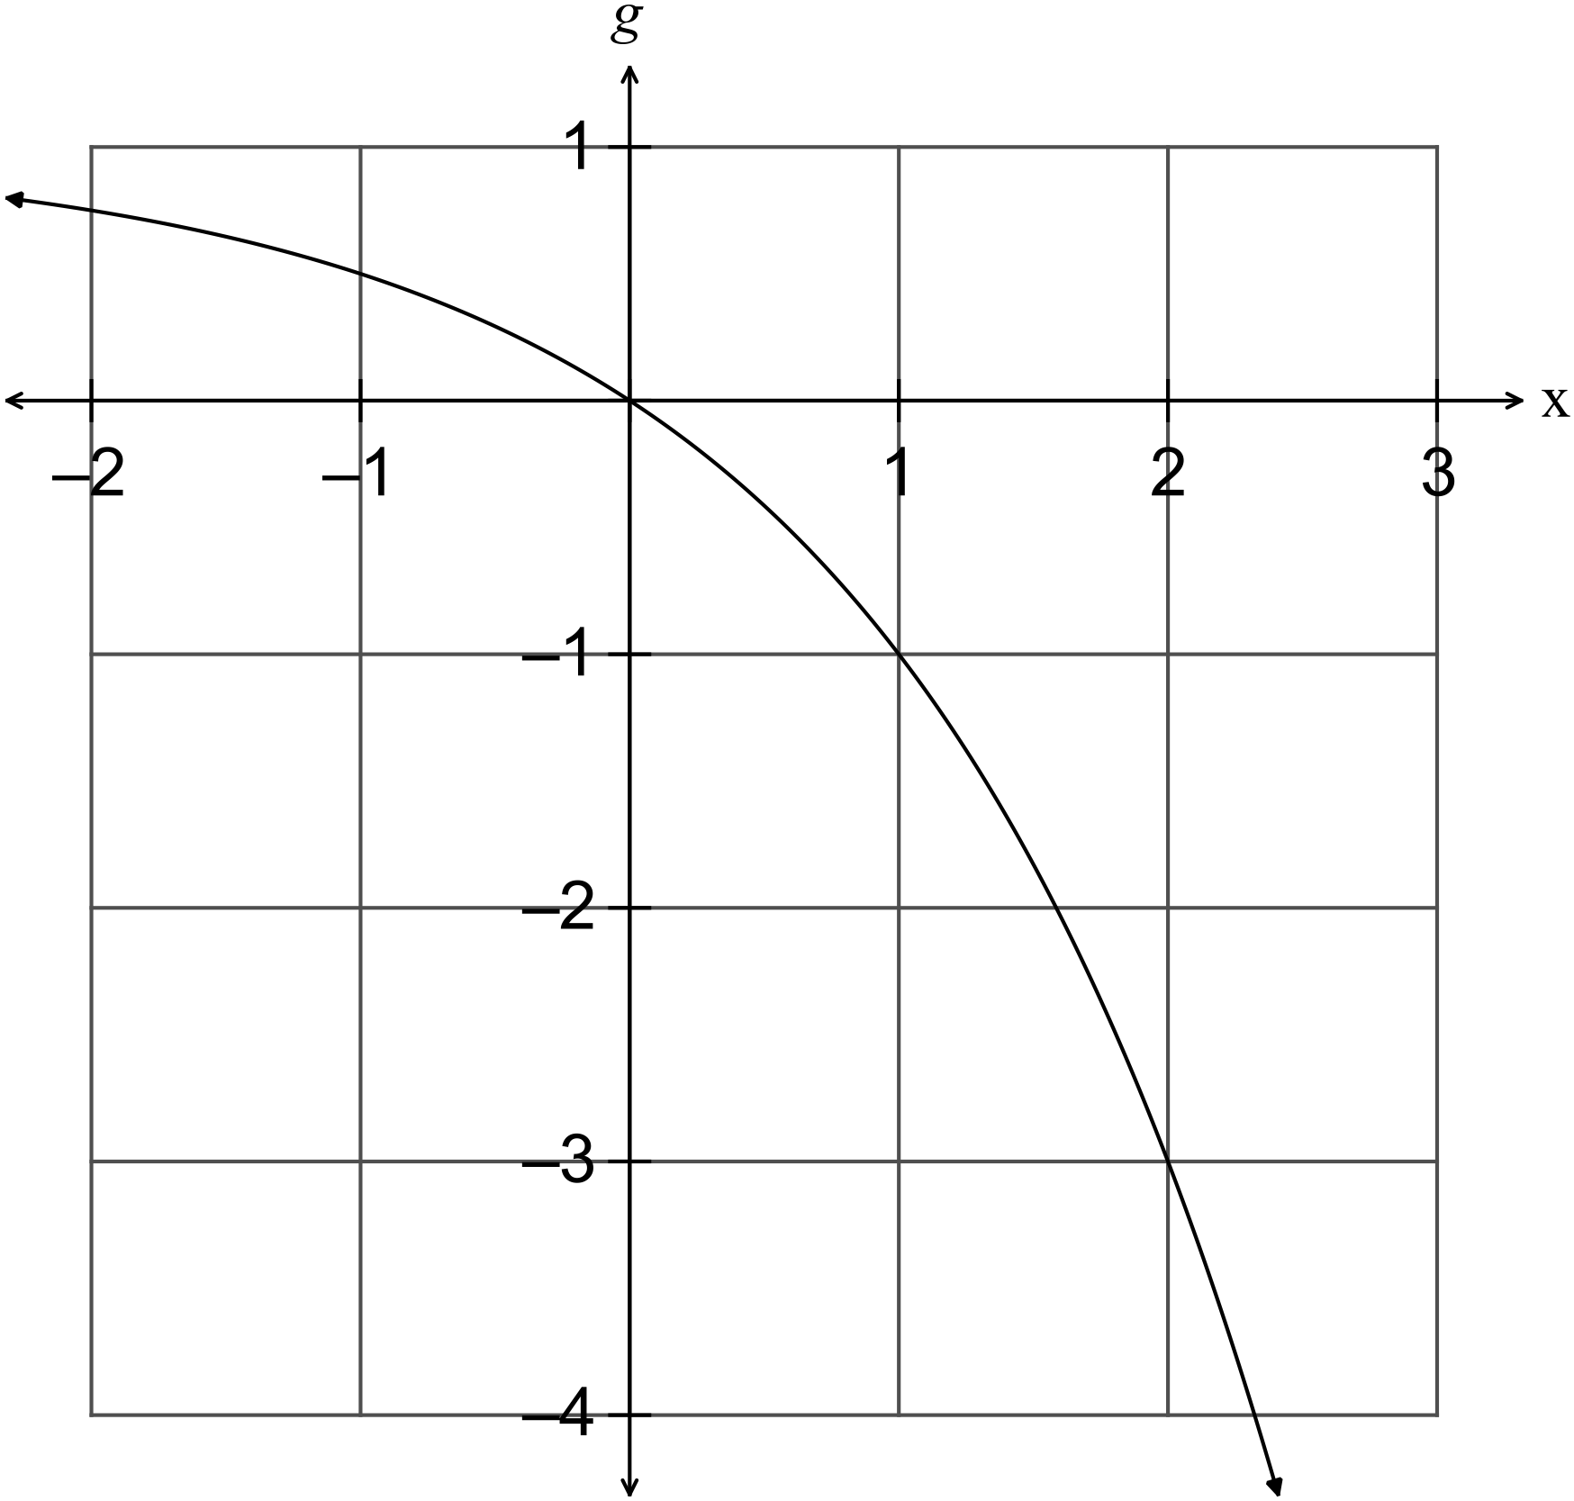
✓
✓
✓
(d) 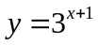 ✓✓✓
SECTION 2 – Calculator-assumed
Question 7 (10 marks)
(a) ✓
✓

(b) A GP with a = 35 000, r =1.05 ✓✓

(c)
✓
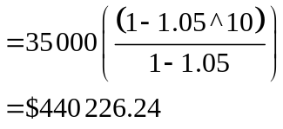
✓
✓

(d) 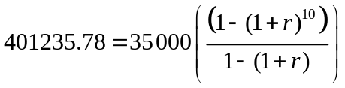 ✓✓

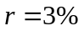 ✓

Question 8 (13 marks)
(a) (i) 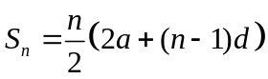
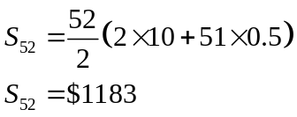
✓
✓✓

(ii) 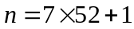
✓
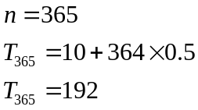
✓
✓
✓
(iii) 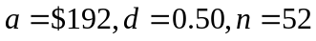
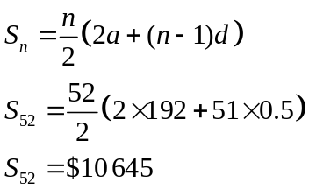
✓
✓
(b) 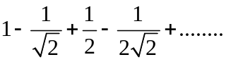
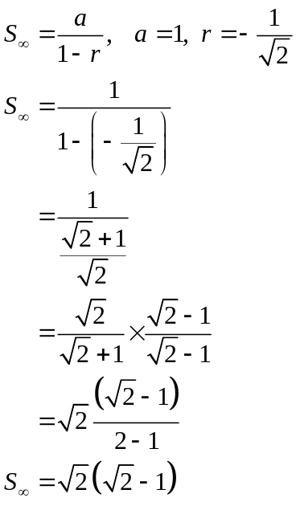
✓
✓
✓
✓

Question 9 (7 marks)
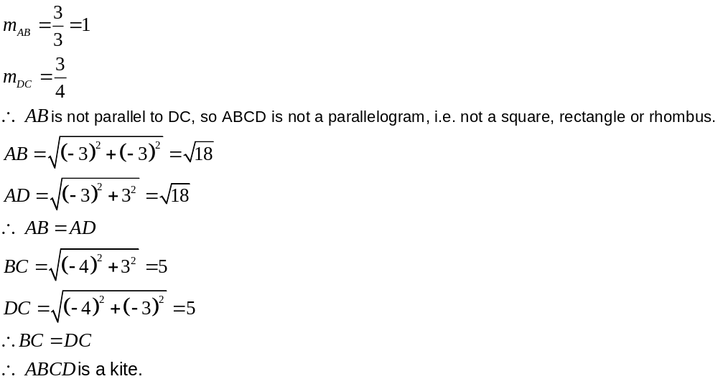
✓
✓✓
✓
✓
✓
✓

Question 10 (8 marks)
(a) 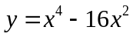.
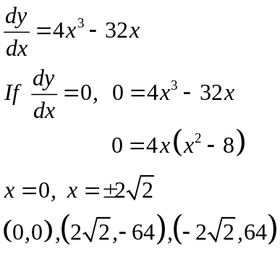
✓
✓
✓

(b) 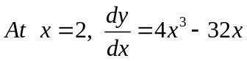
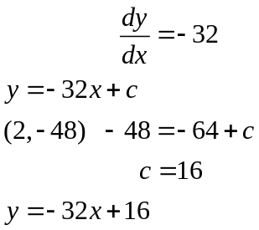
✓
✓

(c) 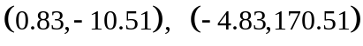
✓
✓

Question 11 (14 marks)
(a) (i) 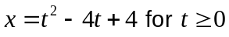
✓
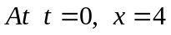
(ii) 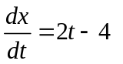
✓

(iii) 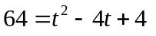
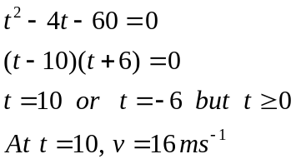
✓
✓
✓
✓
(iv) 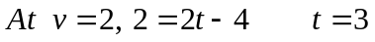
✓
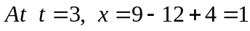

(b) (i)
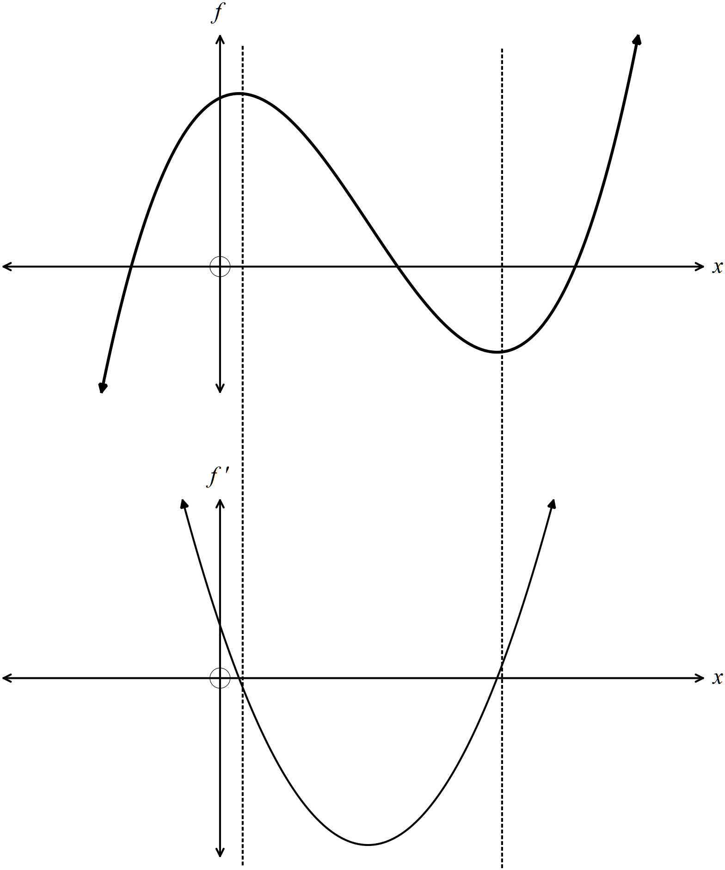
✓
✓
✓
✓
(ii) There is a turning point on f where f ‘(x) = 0, i.e. there are two turning points.
If f’ > 0 just before f ‘(x) = 0, followed by f ’ < 0, then there is a maximum turning
point.
If f ’ < 0 just before f ‘(x) = 0, followed by f ’ > 0, then there is a minimum turning
point.
If f ‘ > 0, the gradient of f is positive.
If f ‘< 0, the gradient of f is negative. ✓✓✓

Question 12 (13 marks)
(a)

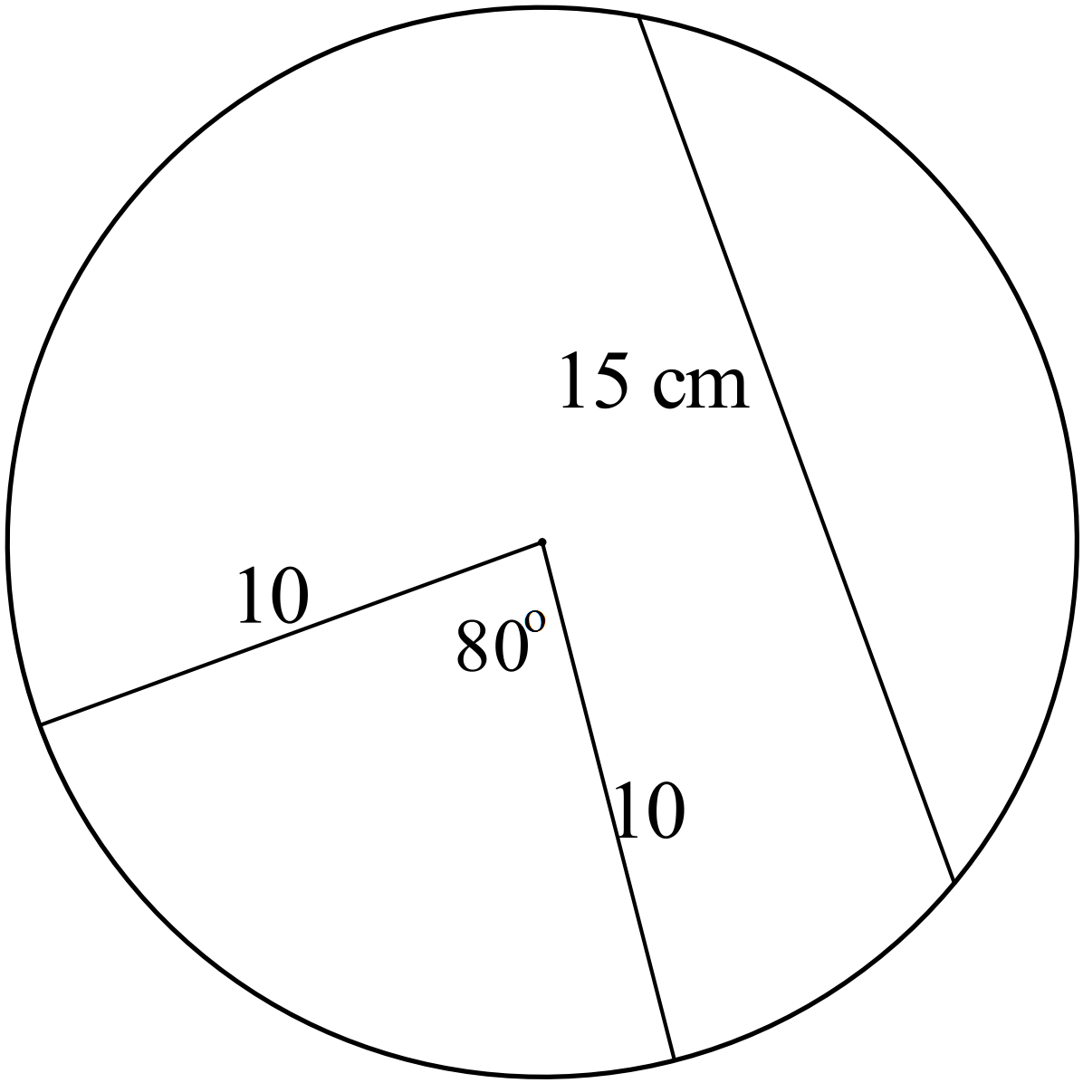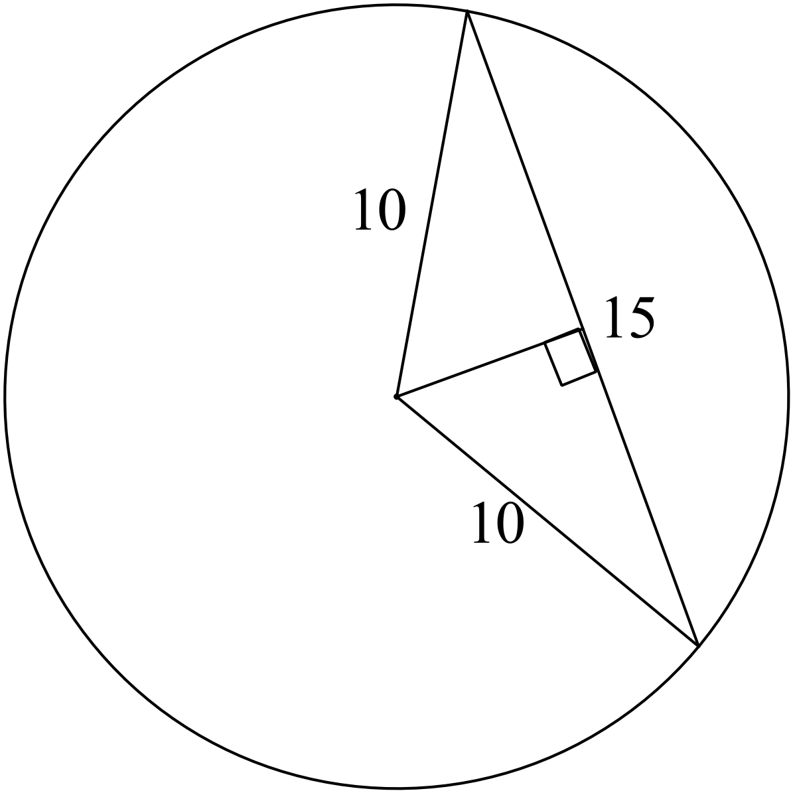
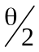

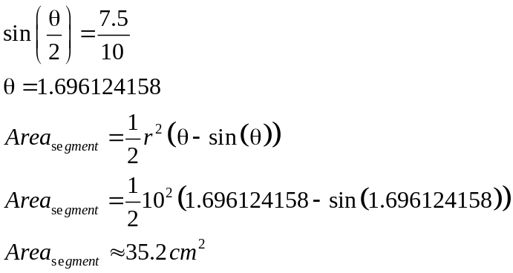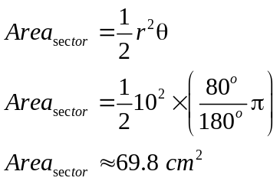
✓
✓
✓
✓
The sector has the bigger area.
(b) 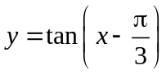 ✓✓
(c)
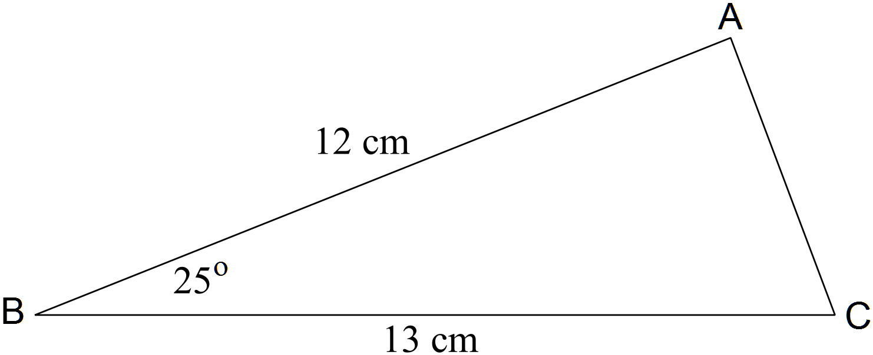
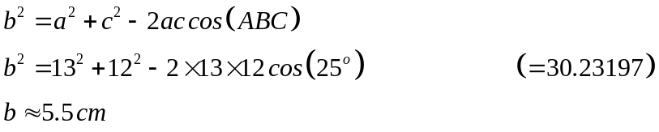
✓
✓

(d) 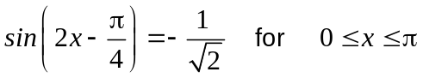
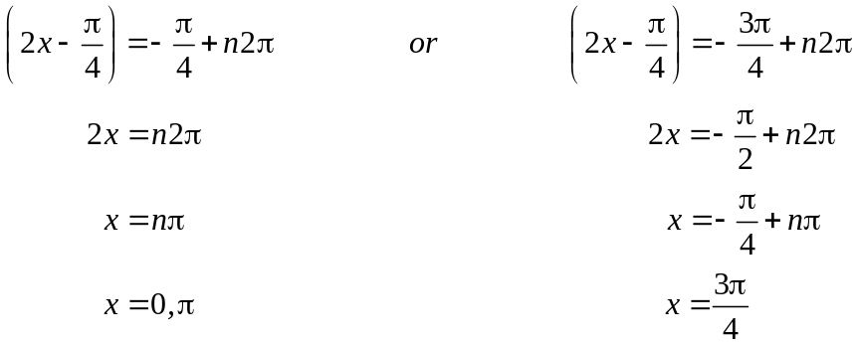
✓
✓
✓

(e)
Put 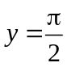
✓
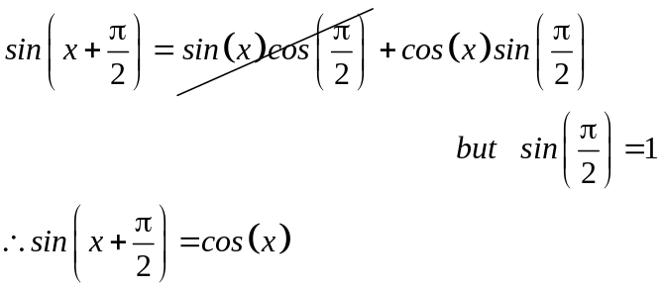
✓

Question 13 (12 marks)
(a) 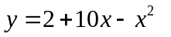
✓

(i) 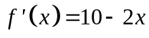
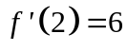
✓

✓

(ii) 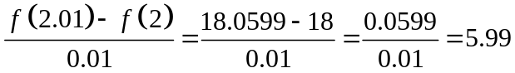
✓

✓

(ii) The answers are similar because 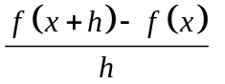approximates the slope at a
point by using the gradient of a very small interval close to the given x value. ✓✓

(b) (i) 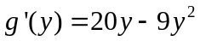 ✓
(ii) 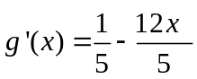 ✓✓
Question 14 (17 marks)
(a) 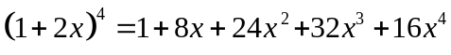 ✓
The coefficient of 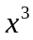 is 32. ✓
✓

(b) (i) A and Q
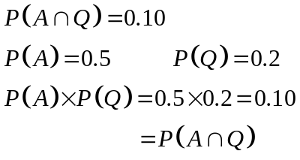
✓

✓

Therefore the events are independent.
✓

(ii) B and R because 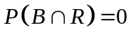
(iii) 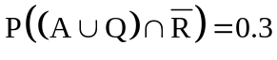 ✓✓

(c) 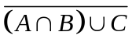
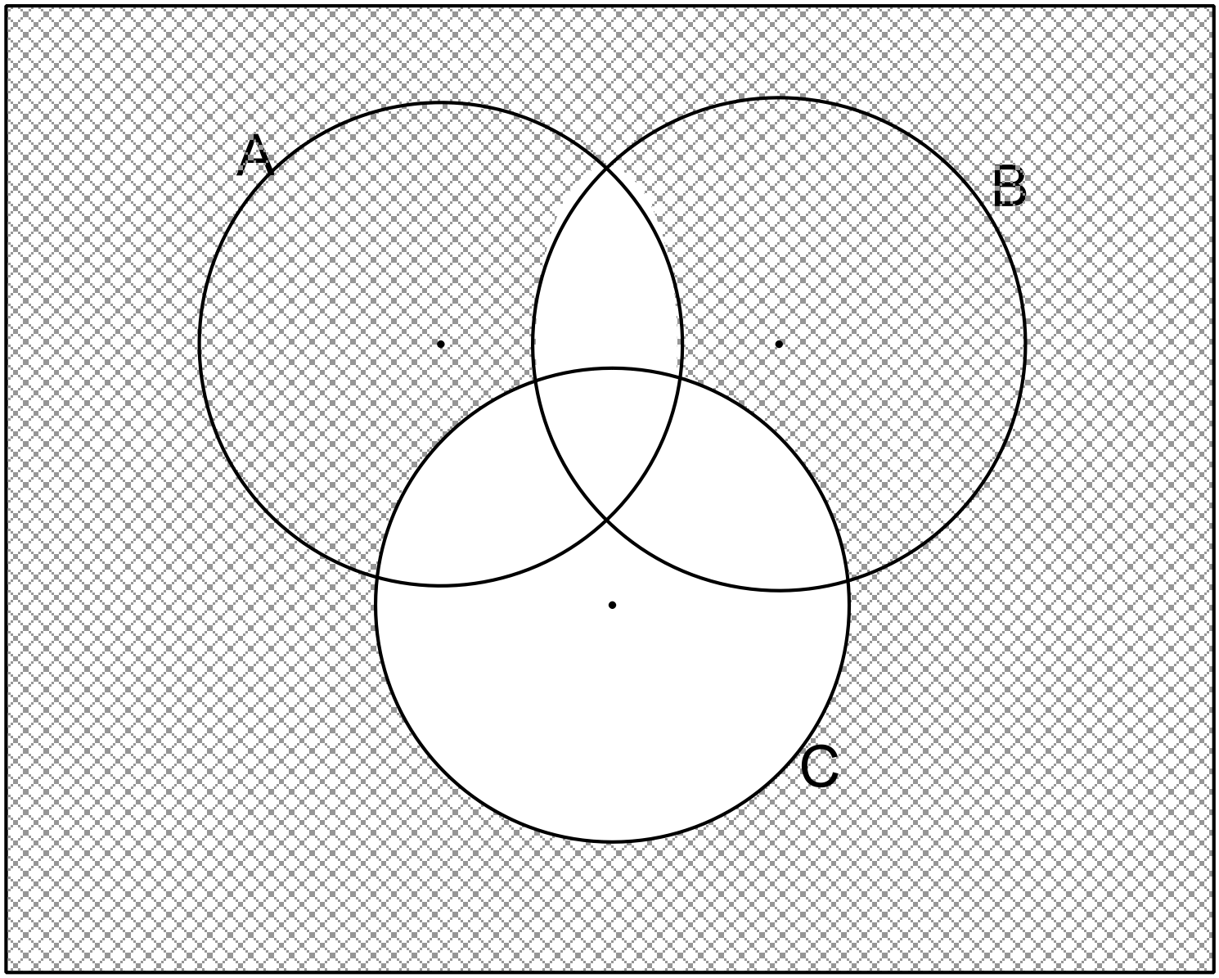 ✓✓✓ -1/error

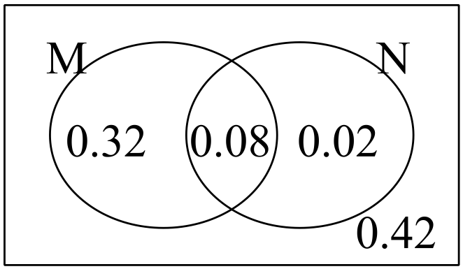(d) (i)
✓

✓
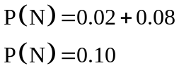
✓
(ii) 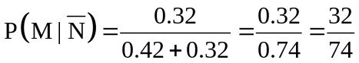
✓
✓

Question 15 (6 marks)
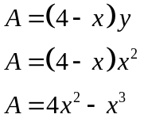
✓
For maximum area 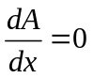
✓
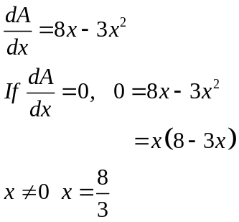
✓
✓
Test for maximum
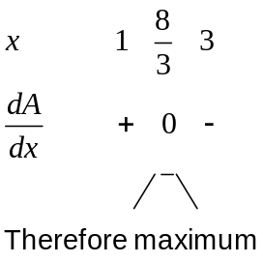
✓
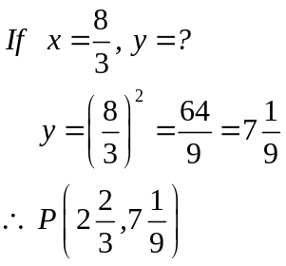
Therefore the dimensions of the maximum sized rectangle are 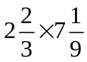. ✓
End of solutions

